Infosys Springboard Virtual Internship 6.0 Completion Report
Batch Number : 5
Start date : 13-Oct-2025
Name : MOHAN RAJ P S
Internship Duration: 8 Weeks

1. Project Title
InsurAI Corporate Policy Automation and Intelligence System

2. Project Objective

1.Automate core insurance workflows such as user onboarding, agent management, plan browsing, and appointment scheduling to reduce manual work.

2.Provide an intelligent, user-friendly digital platform where users, agents, and admins can manage policies, appointments, and communication through a unified dashboard.

3.Improve decision-making and efficiency by using automated email alerts, secure data storage, and smart assistance to enhance transparency and workflow accuracy.

3. Project description in detail
This project focused on digitalize and automate insurance operations for users, agents, and administrators. The project focuses on simplifying policy management, improving communication, and reducing manual workloads through intelligent automation.
Approach:
1. Requirement Analysis & Workflow Planning:
Identified real-world insurance workflows such as user registration, agent onboarding, policy browsing, and appointment booking.
Designed separate dashboards for Users, Agents, Admins.
Planned an automated email system for instant communication.

2. Backend Development:
Designed REST APIs for user login, agent management, plan management, and appointments.
Implemented relational database tables to store users, plans, and appointments.
Added automated email notifications using JavaMailSender.
Ensured secure appointment storage with unique user–agent mapping.

3. Front-End Development :
Created responsive UI components for login, signup, dashboards, appointment booking, and admin features.
Built interactive user and agent dashboards for:
Viewing plans
Managing profiles
Viewing appointments
Implemented fetch calls to communicate with the Spring Boot API.

4. Integration & Testing:
Integrated frontend with REST endpoints and tested workflows end-to-end.
Validated email delivery, appointment storage, and user access roles.

Technologies Used:
1.Frontend - React.js,Css ,React Router DOM,Fetch API.

2.Backend - Spring Boot,Spring Web,Spring Data JPA (Hibernate),Spring Mail,Java 17.

3.Database - MySQL,JPA Repository.

4.Tools - Postman for API testing,VS Code,Eclipse IDE,GitHub for version control.

4. Timeline Overview
Week | Activities Planned | Activities Completed
Week 1 | user authentication pages. | Developed user authentications.
Week 2 | Home page and integrate Login,sign up,about and features components in that. | Developed Home page.
Week 3 | user dash board. | User dash board and all other functionalities.
Week 4 | appointment booking interface and integrate email service. | Put appointment booking screen and email is integrated.
Week 5 | Admin dashboard. | Put Admin dashboard and functionalities.
Week 6 | Plan management system. | Builded a responsive plan management component.
Week 7 | Agent dashboard. | Simple agent dashboard is created.
Week 8 | Backend to store and view appointments. | Developed backend and frontend for storing and viewing agent appointments.

5a. Key Milestones
Milestone | Description | Date Achieved
Project Kickoff | Learn React and spring boot concepts,Understand the project,develop login,sign up and home page using react.
Prototype/First Draft | learn to develop backend and sql database connection,  learn React Router for navigation,develop user dashboard,  learn how to develop fromal and modern UI for componets.
Mid-Term Review | Developed Admin Dashboard-Analysis,  Plan management system.  Developed Appointment scheduling  inteferace in user dashboard.  Learn how to send gmail to user and agents  using java mailsender class to notify about  their appointment.
Final Submission | Developed all modules and ensure the project workflow.
Presentation | Prepared with documentation report and presentations.

5b. Project execution details
The development of the InsurAI Corporate Policy Automation and Intelligence System was completed step-by-step, ensuring both frontend and backend worked smoothly together. The entire project was executed using an organized approach to achieve a functional and user-friendly system.

1. Requirement Understanding & Planning:
First, I analyzed what users, agents, and admins needed in an insurance workflow.
I separated the system into modules such as authentication, plan management, appointment booking, and dashboards.
A basic workflow diagram was created to decide how data will flow between the backend, and database.

2. Backend Development :
Created REST APIs for login, user/agent registration, plan management, and appointment booking.
Implemented email notifications using JavaMailSender so users and agents receive instant booking updates.
Added database integration using Spring Data JPA to store appointment records, user details, and plans.
3. Frontend Development :
Designed separate dashboards for User, Agent, and Admin using reusable components.
Developed appointment-booking UI where users select an agent and date.
Created an Agent Dashboard to fetch and display agent-specific appointments.
Implemented responsive design so all screens work smoothly on web.

4. Deployment :
Verified final system performance by testing workflows end-to-end.
Ensured all dashboards show correct real-time data.
Cleaned UI design and improved styling for better readability and user experience.

6. Snapshots / Screenshots
1.Login Page
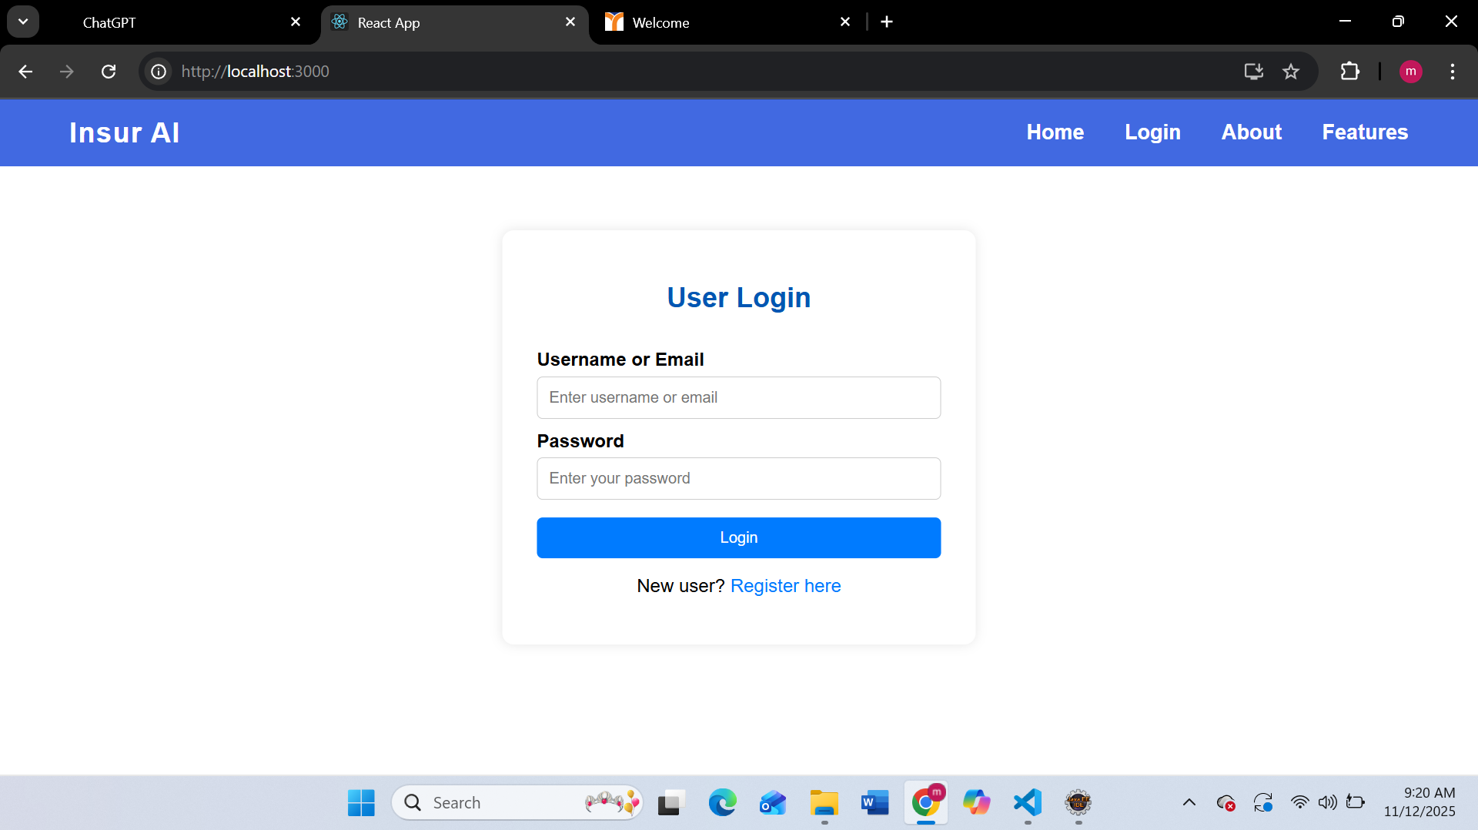
2.Dashboard
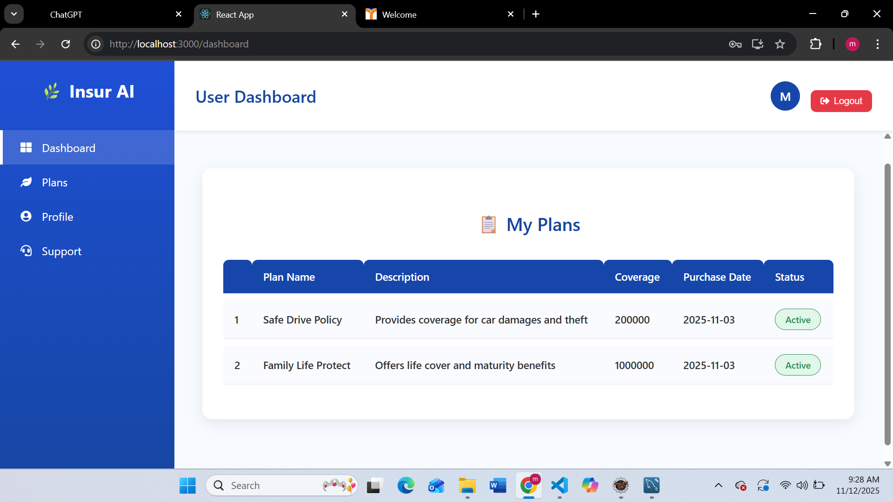
3.Appointment booking interface
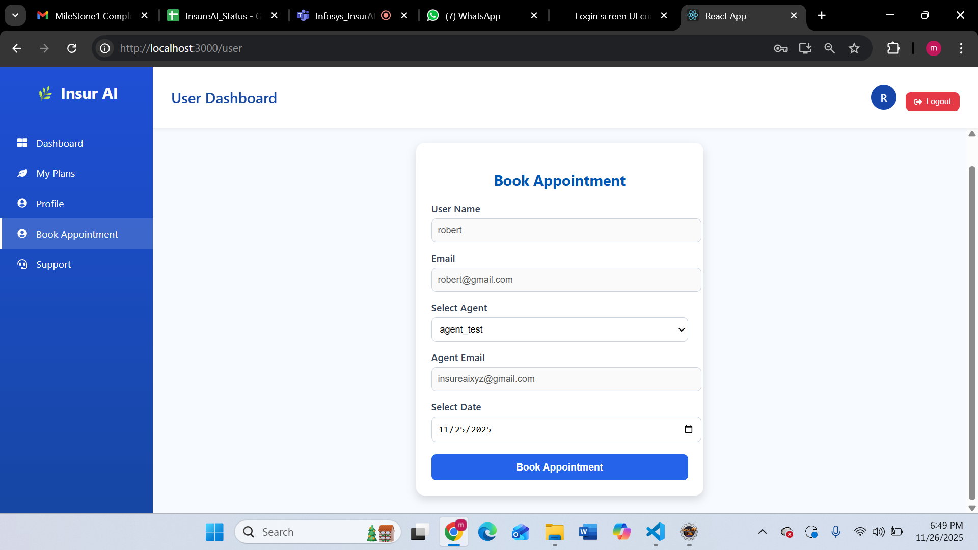

4.Email Service
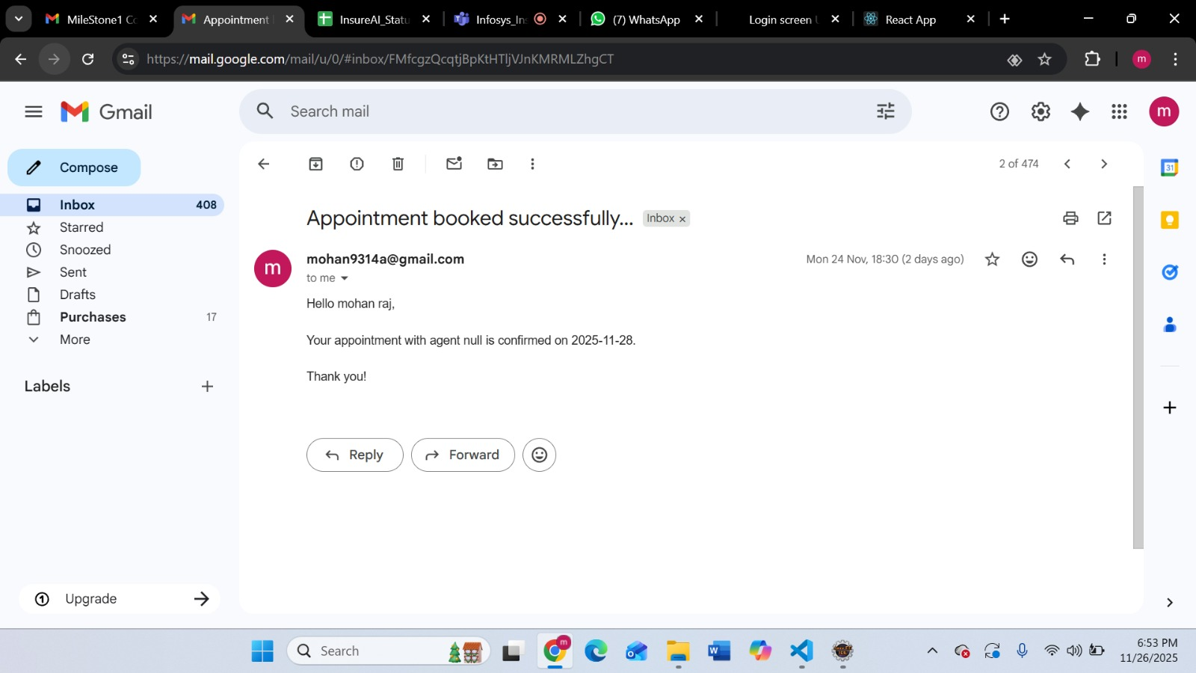

7. Challenges Faced

1.Initially, the email service and appointment storage logic were not connected properly. By restructuring the controller and repository, I resolved the issue and achieved smooth data flow.

2.There were cases where agent details became undefined while booking appointments. Adding proper state checks and validating fetched data fixed the issue.

3.Some components like the sidebar and appointments table did not follow the expected design. By creating separate CSS files and adjusting layout properties, the UI became consistent across pages.

9. Testimonials from team

1.Gained Hands-on Project Experience:

I successfully developed a complete insurance automation system, which helped me understand real-world software development and teamwork practices.

2.Improved Technical Skills:

Working with Spring Boot, React, MySQL, and automation workflows strengthened my full-stack development skills.

3.Positive Team Feedback:

My team appreciated how I implemented features like email automation, agent dashboard, and appointment booking with accuracy and clean logic.

4.Boosted Confidence & Professional Growth:

This project improved my problem-solving ability, communication skills, and confidence to handle larger projects independently.

10. Conclusion

This internship was a highly valuable learning experience. Throughout the development process, I gained practical skills in full-stack development, backend automation, database handling, and real-time communication using email notifications. The project allowed me to understand how digital automation can simplify complex insurance workflows and improve customer and agent interactions.

Working on this system strengthened my problem-solving ability, improved my coding confidence, and helped me learn how to build user-friendly interfaces and secure backend logic. This internship directly supports my academic goals in software engineering and prepares me for a professional career in full-stack development. Overall, the experience increased my technical knowledge, boosted my teamwork approach, and gave me confidence to work on real-world industry projects.

11. Acknowledgements
I would like to express my sincere gratitude to Infosys for giving me the opportunity to work on this internship project. This experience has been extremely valuable for my technical and professional growth.
I extend my heartfelt thanks to my mentor Senthil Subramanian for their constant guidance, support, and constructive feedback throughout the project.

